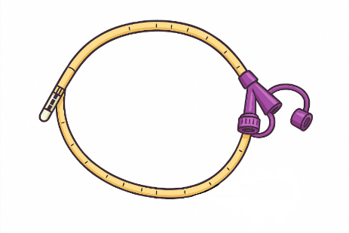
 ᕿᑐᙵᕕᑦ ᓱᕐᓗᒃᑯᑦ ᓱᓪᓗᓕᖕᒧᑦ ᖃᐅᔨᓴᕈᑎ
ᕿᑐᕐᖓᒪ ᓂᕆᑎᑦᑎᔾᔪᓯᖓ ᐅᑯᐊᖑᕗᖅ:

ᕿᑐᕐᖓᒪ ᓂᕆᑎᑕᖏᑕ ᖃᐟᓯᐅᓂᖓ___________mL-ᖑᕗᖅ

ᕿᑐᕐᖓᒪ ᓂᕆᑎᑉᐸᓪᓕᐊᓂᖓ ___________ mL/h, ᓂᕆᑎᑕᐅᓂᖓᑕ ᐊᑯᓂᐅᑎᒋᓂᖓ
________ᒥᓂᑦ.
ᕿᑐᕐᖓᒪ ᓂᕆᕕᖏᑦ ᐅᑯᐊᖑᕗᑦ__________________________________________________

ᓂᕆᔾᔪᑎᒃᓴᒃᑲ ᑎᑭᓐᓂᐊᖅᑐᑦ ᐅᑯᓇᙵᑦ________________________________________________

ᐊᑐᕈᓂ ᐅᕌᓪᓗᐊᓐᓂᒃᑯᑦ ᓂᕆᑎᑦᑎᓂᕐᒥᒃ: ᕿᑐᕐᖓᕋ _______ ᑯᑐᖅᑕᕐᓂᐊᖅᑐᖅ ᒥᓂᑦᑕᒫᑦ.

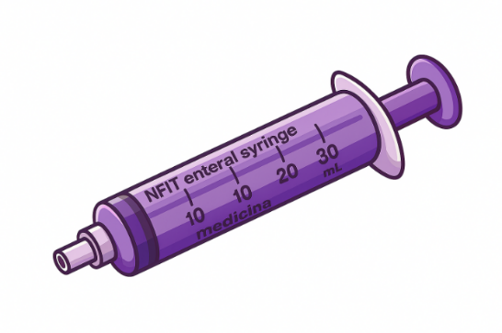
ᕿᑐᕐᖓᒪ ᑯᐊᖅᑎᑦᑎᔾᔪᑎᒋᕙᒃᑕᖓ
___________mL ᓯᕗᓂᐊᒍᑦ ᑭᖑᓂᐊᒍᓪᓗ ᓂᕆᑎᑕᐅᕌᖓᑦ

___________mL ᐊᑐᓂ ᐃᓅᓕᓴᐅᑎᓄᑦ

ᖃᐅᔨᒪᔪᕐᔪᐊᖑᕗᑎᑦ ᕿᑐᕐᖓᕐᓄᑦ. ᑕᒫᓃᑉᐳᒍᑦ ᐃᓕᖕᓂᒃ ᐃᑲᔪᕈᒪᓪᓗᑕ ᑲᙱᒋᑦᑎᐊᕐᓂᕐᒥᒃ ᐃᑲᔪᖅᑐᖅᑕᐅᓂᕐᒥᓪᓗ ᖃᓄᓕᒫᖅ ᑲᒪᒋᔭᐅᓂᖏᓐᓂ!
ᐃᓕᑦᑎᕙᓪᓕᐊᓂᕐᒧᑦ ᑐᕌᕆᔭᐅᔪᑦ | ᐊᔪᙱᑕᖃᕐᓂᖅ ᑕᑯᒃᓴᐅᑎᑦᑎᓗᓂ | ᐱᔭᕇᖅᓯᒪᔪᖅ ✔️
NG ᓱᓪᓗᓕᖕᒥᒃ ᑲᒪᒋᔭᖃᕐᓂᖅ
ᓂᐱᓕᐅᕆᓂᖅ ᓂᐱᓕᐅᕆᒃᑲᓐᓂᕐᓂᕐᓗ NG | ᑕᑯᒃᓴᐅᑎᑦᑎᓗᓂ ᐊᑦᑕᕐᓇᙱᑦᑐᒥᒃ ᓂᐱᓕᐅᕆᓂᕐᒥᒃ
ᓱᓪᓗᓕᖕᒥᒃ ᐆᒃᑐᕋᐃᓂᖅ | ᓇᓗᓇᐃᕐᓗᒍ ᑕᒻᒪᖅᓯᒪᙱᑦᑐᖅ ᐆᒃᑐᕋᐅᑎ
pH-ᒧᑦ ᓇᓗᓇᐃᖅᓯᓂᖅ | ᖃᐅᔨᒋᐊᕐᓗᒍ pH-ᖓ ᓇᓗᓇᐃᕐᓗᒍᓗ ᓇᓃᓐᓂᖓ
ᓂᕆᑎᑦᑎᓂᖅ
ᐊᐅᓚᑦᑎᓂᖅ ᓂᕿᓂᒃ / ᓂᕆᑎᑦᑎᓂᖅ | ᒥᓪᓗᐊᕈᑎᓕᐅᕐᓂᖅ / ᐅᕌᓪᓗᐊᓐᓂᖓᓂᒃ ᓂᕆᑎᑦᑎᓂᖅ / ᐱᒋᐊᕐᕕᒃ ᓄᖅᑲᖅᑎᑦᑎᓂᕐᓗ
ᑯᐊᖅᑎᑦᑎᕙᓪᓕᐊᓂᖅ NG-ᒥᒃ | ᖃᖓ ᖃᓄᕐᓗ ᑯᐊᖅᑎᑦᑎᔪᓐᓇᕐᒪᖔᑦ
ᓴᓗᒻᒪᖅᓴᐃᓂᖅ ᑲᒪᒋᔭᖃᕐᓂᕐᓗ ᐱᖁᑎᓂᒃ
ᓴᓗᒪᔪᖅ ᓂᕆᔾᔪᑎᐅᑉ ᐳᖓ | ᑕᑯᒃᓴᐅᑎᑦᑎᓗᓂ ᑕᒻᒪᖅᑕᙱᓪᓗᓂ ᓴᓗᒻᒪᖅᓴᐃᔾᔪᓯᕐᒥᒃ
ᓴᓗᒪᔪᑦ ᑲᐴᑎᑦ | ᐅᐊᓴᑦᑎᐊᖅᐸᒡᓗᒋᑦ ᐸᓂᖅᓯᑦᑎᐊᖅᐸᒡᓗᒋᓪᓗ
ᐃᓅᓕᓴᐅᑎᑦ (ᐊᑐᖅᑕᐅᔪᒃᓴᐅᑉᐸᑦ)
ᐃᓅᓕᓴᐅᑎᓂᒃ ᐱᓰᔭᐃᓯᒪᓗᑎᑦ | ᕿᒥᕐᕈᐊᒃᑲᓐᓂᕐᓗᒋᑦ ᑕᒻᒪᖅᑕᖅᓯᒪᙱᑦᑐᑦ ᐱᕙᒌᔭᕐᓂᕐᒧᑦ ᐊᑐᖅᑕᐅᕙᓪᓕᐊᕙᒃᑐᑦ
ᐃᓅᓕᓴᐅᑎᓂᒃ ᑐᓂᓯᕙᓪᓗᓂ / ᐊᐅᓚᑦᑎᕙᓪᓗᓂ | ᐃᓅᓕᓴᐅᑎᓂᒃ ᑐᓂᓯᑦᑎᐊᖅᐸᒡᓗᑎᑦ NG-ᑯᑎᒍᑦ
NG ᓱᓪᓗᓕᖕᒥᒃ ᐃᓕᐅᖅᑲᐃᓂᖅ
ᕿᒥᕐᕈᓂᕐᒧᑦ ᐃᓕᐅᖅᑲᐃᓂᖅ | ᐅᖃᐅᓯᕆᓗᒋᑦ ᖃᓄᐃᓕᐅᖅᑕᐅᕙᓪᓕᐊᕙᒃᑐᑦ, ᖁᐊᖅᓵᕐᓇᖅᑕᐃᓕᒪᓂᖅ, ᐃᓗᐊᖅᓴᕐᓂᕐᒧᑦ ᐊᑐᖅᑕᐅᕙᒃᑐᑦ
ᐊᔪᕈᓐᓃᖅᓴᐅᑎᓂᒃ ᐃᓕᐅᖅᑲᐃᓂᖅ | ᐃᓕᓗᒍ NG ᕿᑐᕐᖓᐅᔭᓐᖑᐊᒧᑦ
ᐃᒻᒥᒃᑯᑦ ᐃᓕᐅᖅᑲᐃᓂᖅ | ᐃᓕᓗᒍ NG ᓱᓪᓗᓕᒃ ᐃᒻᒥᒃᑯᑦ
ᐊᑲᐅᙱᓕᐅᕈᑎᓂᒃ ᐋᖅᑭᒃᓱᐃᓂᖅ / ᖃᐅᔨᓇᓱᐊᕐᓂᖅ
NG-ᒧᑦ ᐊᑲᐅᙱᓕᐅᕈᑕᐅᒐᔪᒃᑐᑦ | ᓇᓗᓇᐃᖅᓯᕙᓪᓗᓂ ᐊᐅᓚᑦᑎᕙᓪᓗᓂᓗ ᐃᓱᒫᓘᑎᓂᒃ
ᐱᖁᑎᑦ
ᑎᑭᓴᐃᓂᖅ ᐱᖁᑎᓂᒃ | ᖃᐅᔨᒪᔪᖅ ᖃᓄᖅ ᓇᑭᓪᓗ ᑎᑭᓴᐃᔭᕆᐊᒃᓴᖅ
ᐱᖁᑎᓂᒃ ᑎᑭᕝᕕᐅᓂᖅ | ᑐᑭᓯᐅᒪᓗᓂ ᐊᔾᔭᖅᓯᓂᕐᒧᑦ/ᐊᐃᓪᓕᕐᓂᕐᒧᑦ ᑲᔪᓯᓂᕆᔭᐅᕙᒃᑐᒥᒃ
ᐊᑐᕈᓐᓃᖅᑎᑦᑎᓂᖅ ᐱᖁᑎᓂᒃ | ᑭᓇᒧᑦ ᖃᐅᔨᒋᐊᕈᓐᓇᖅᐱᑕ ᕿᑐᕐᖓᕐᒪ ᓱᓪᓗᓕᖓ ᐊᑐᖅᑕᐅᔭᕆᐊᖃᙱᑉᐸᑦ

