Council Policy No.: | CP2026-013 (formerly CP2021-047 and CP2018-001)
Council Policy Name: | Dock Encroachments
Date Approved by Council: | February 13, 2018
Date revision approved by Council: | November 16, 2021  March 24, 2026  CR2026-103
Related SOP, Management Directive, Council Policy, Forms

Policy Statement and Rationale:

The Corporation of the City of Kawartha Lakes requires policies and procedures to regulate dock and boathouse encroachments onto City-owned land. This policy statement sets out the philosophy, principles and procedures for the management of privately-owned docks on land owned by the Corporation. This policy is to be used in conjunction with the City Lands Encroachment By-law.

Section 270 of the Municipal Act, 2001 requires municipalities to adopt policies regarding the sale and other disposition of municipally owned land. To promote consistent, transparent and equitable processes in disposal in a manner consistent with the best interest of the City.

Scope:

This policy covers all real property owned or to be acquired by The Corporation of the City of Kawartha Lakes that are adjacent to water (including, but not limited to, waterfront parcels, road allowances, and shoreline road allowances).

Definitions:

Dock: a structure extending along the shore or out from the shore into a body of water, to which boats may be moored or by which people can access the water (where a dock is licensed, associated stairs, marine rail systems, retaining walls and boatlifts without hard tops or sides are included in the license)

Boathouse: a structure at the edge of a body of water used or intended for housing boats or gear for water enjoyment, including a structure that consists of a solid roof (whether or not the structure has any solid walls) (where a boathouse is licensed, associated stairs, marine rail systems, retaining walls and boatlifts without hard tops or sides are included in the license)

All definitions herein are as set out in the City Lands Encroachment By-law and the Land Management Policy.

Background:

In 2010, the City passed the following resolution:

Moved by Councillor Luff, seconded by Councillor Strangway,
RESOLVED THAT Report LMC2010-048, “Unauthorized Dock Placement on Municipally Owned Land within the City of Kawartha Lakes”, be received; and
THAT staff be directed to develop an Encroachment Policy for docks on municipal property based upon the following principles:
- THAT such a policy be structured to deal with matters on the basis only where access to waterfront is being adversely affected;
- THAT such a policy be structured to protect the general public’s interest in access to the waterfront;
- THAT such a policy be structured to ensure the municipality’s rights as landowner, along with protecting the municipality from liability;
- THAT such a policy contemplate a license, permit or encroachment agreement process for those residents wishing to ensure longer term use of municipal property and where previously referenced principles are not impacted; and
THAT staff be directed to bring forward a report to Council in 2011 with a DRAFT policy as outlined above.
CARRIED CR2010-1206

In 2018, the City passed the Encroachment By-law 2018-017 and the Docking Policy CP2018-001.

Philosophy:

The City will proactively manage private docking on City owned land at Kenstone Beach, Hazel Street (Thurstonia), Cedar Glen Road and Hickory Beach, in response to concerns of overcrowding in those areas. Private docks and boathouses on City property in the balance of the geographic boundaries of the City may be licensed upon request by individual dock owners, where there is a travelled road between the dock/boathouse and the associated private property.,

Approval for a license with a 5-year term will issue where the conditions to approval have been met:

- Use does not adversely affect the use by others of the property (shoreline use will not be exclusive; dock use exclusive)
- Use does not adversely affect the ability of the City to use, access and maintain its property
  - Structures should be set back 3 m from the edge of the travelled road. Existing structures within 3 m of the travelled road will be asked to relocate away from the travelled roadway at the time of a major repair, if possible.
- Use does not adversely affect the ability of the general public to use the area adjacent to the dock, and to access the water
- Use does not result in overcrowding of the waterfront
  - A minimum of 6 feet should be maintained between adjacent docks, where possible
  - Dock owners must live in the neighbourhood where the dock is located. The Neighbourhood for Hazel Street and Cedar Glen Road is set out in maps appended to this Policy at Schedules A and B. For the balance of the City, the Neighbourhood will be that area within 400 metres of the dock.
- The City will license existing docks and boathouses only. The City will not approve the construction of new privately-owned docks and boathouses on City property where a historical use did not exist.
  - Eligible dock owners will only be eligible for one dock
  - Waterfront property owners will not be eligible for a dock on City land
- Use does not adversely affect the aesthetics of the area
- Federal and provincial permits are the obligation of the dock owner
- In areas regulated by Trent-Severn Waterway, licenses may only be granted if the City is able to obtain a Waterlot Licence from Trent-Severn Waterway
- Use does not result in erosion or degradation of fish habitat
- Existing crib docks to be replaced with post/ floating docks upon repair
- Continued obligation to maintain and insure dock
- Fees: Fees shall be in accordance with the Consolidated Fees By-law and are subject to annual increases. As of January 1, 2026, applicable fees are $150.00 application to the Realty Services Division + $155.00 per year for a dock and/or $415.00 per year for a boathouse
  - Associated stairways, boat lifts, hydro, water intakes, retaining walls, elevated decks and multi-story decks are to be identified in the license agreement and included in the base payment
- Any additional costs/fees (e.g. surveys, federal or provincial permits, etc.) are the responsibility of the dock owner
- Obligation to post permit number on dock and notice of private property (in areas where ownership is unclear)

Upon default of any condition, can be revoked on 30 days’ notice. Structures left following deadline for removal will be abandoned and City may remove and charge the applicant for the costs of demolition and removal (pursuant to the City Lands Encroachment By-law).

In the case of a request for a license of a dock on a road allowance leading to water:

A license will only be issued if the road allowance is a minimum width of 20 metres/66 feet at the water’s edge (subject to Trent-Severn Waterway issuing a Waterlot Licence to the City). Otherwise, the request for a license will be denied unless Trent-Severn Waterway is willing to issue a waterlot license and the property owners on either side of the road allowance have been contacted and are in support of the dock. The dock license that issues in this circumstance will not allow for overnight docking, the dock itself will be open for use by the public at large regardless of the fact that it is privately maintained, licensed and maintained.

In the case of a request to legalize a dock on a shoreline road allowance with no travelled road thereon:

A license will not be offered in this scenario. Instead, where a sale of the adjacent portion of the shoreline road allowance is supportable (review to the Disposition of Land By-law and Policy for guidance), this will be the solution offered.

In the circumstance that a property owner is able to prove to the satisfaction of the Manager of Realty Services that they have attempted to finance and are unable to finance (including with property title insurance) the purchase of the shoreline acquisition, and thus are financially unable to acquire the road allowance, a Lease Agreement may be offered on the following conditions:

- 5-year term, no renewal
- Lease shall not be transferable to subsequent owners of the adjacent property
- Lease rate shall be at fair market value as determined by the Realty Services Division and shall be no less than triple the payment that would otherwise be made for a license agreement, given the same encroachments
- Lessee shall indemnify the City for any costs or expenses the City may be put to as a result of the encroachment, including but not limited to, any provincial order for failure to obtain a Works over Water permit per the requirements of the Public Lands Act
- Lease shall not entitle the lessee to injure, cut, or remove mature trees within the meaning of the City Lands Tree Preservation By-law
- Lessee shall not be entitled to expand or modify its encroachments or discharge any contaminants into the shoreline road allowance or adjacent water body
- Lessee must remove any encroachments not permitted by the Trent Severn Waterway, Conservation Authority, or Ministry of Natural Resources, as the case may be (i.e. crib docks; sand/stone at the shoreline)
- The Lessee shall be required to pay for all costs of the Lease, including but not limited to, survey costs, appraisal costs (if required by the Realty Services Division to determine fair market value), and a staff time fee of $750.00

In the event that the property owner is unable to purchase or lease the shoreline road allowance, the encroachments will be required to be removed.

Procedure for Individual Application for a License/Lease/ Shoreline Purchase:

Where persons approach the City to obtain approval for an existing dock on City property, the following procedure is followed:

- An application is made to the Realty Services Division.

- The Realty Services Clerk may take the matter to the next regularly scheduled Land Management Team – which meets every other month – for review, if direction is required.

- The Realty Services Division/Land Management Team analyzes the offer, considering the philosophy set out in this Policy.

- If the Land Management Team does not agree on treatment of a matter, then the Realty Services Manager shall determine the direction to be taken.

- Where a decision has been rendered not in favour of the applicant, the Ward Councillor will be notified of the decision.

- Where a decision has been rendered in favour of the applicant, the Realty Services Division will notify the applicant of the decision, and the costs of proceeding with the application. If a survey is required by the Realty Services Division, then a deposit sufficient from the applicant to cover the costs will be required along with the costs of the license prior to proceeding.

- Once all costs are collected, the Realty Services Division will provide a license/ lease for execution to the applicant, or will commence the process for land disposition in accordance with the Disposition of Land By-Law and Policy. Once an executed license/lease and certificate of insurance is received by the Realty Services Division, the City Solicitor will execute the license/lease in accordance with the Signing Authority By-law.

Enforcement by Municipal Law Enforcement Office

Where a complaint is made about a dock or boathouse on City property, the Municipal Law Enforcement Office will consider this policy and the Encroachment By-Law, and seek guidance from Realty Services Division if required when determining the best course of action for enforcement of the Encroachment By-law. The Municipal Law Enforcement Office may advise the owner that they have 30 days to remove the dock or make application to the Land Management Team for a license/lease/shoreline purchase, as appropriate, or face removal, in accordance with the Encroachment Policy. If an application is made, the above process is followed.

Financial Considerations: Accounting for Proceeds from Dock Licenses

In all circumstances, the proceeds from the license or lease of municipal property will be deposited into general revenues to offset the cost associated with licensing and enforcement.

Council may direct the net proceeds from the license or lease of any municipal property in a manner not provided for in this Policy.

Revision History:

Revision | Date | Description of changes | Requested By
0.0 | February 13, 2018 | Initial Release
0.1 | November 16, 2021 | Updated background and updated the reference to Land Management Team  Confirm areas within the City where proactive enforcement of the Encroachment By-law 2018-017 is being enforced and where licensing is required for docks and boathouses. Propose to add Cedar Glen to the list of areas being proactively enforced.  Clarification that licenses will issue for existing docks; not new docks  Clarification that associated hydro, water intakes, staircases, retaining walls, decks and multi-storey decks are included in the license fee for a dock or boathouse.  Updated application process so that matters can be decided by the Realty Services Division if guidance by the Land Management Team is not required.  Increased annual license fee for a boathouse from $150 to $400  Added target/ non-mandatory spacing between adjacent docks  Added target/ non-mandatory spacing between structures and travelled roadway  License revenue to be placed in general revenues; not into a reserve
0.2 | March 24, 2026 | Refined scope to clarify that this policy applies to City-owned properties that are adjacent to water  Removed the transfer restriction from 800 series residences in Cedar Glen (per CR2023-228)  Added condition regarding City’s requirement to obtain a Waterlot Licence from TSW prior to licensing individual docks  Updated payment section to note that all fees are in accordance with the Consolidated Fees By-law and subject to annual increases  Added requirements related to requests for a Dock License on a road allowance leading to water  Added requirements related to requests for a Dock License on a shoreline road allowance without a travelled road located thereon  Added a lease option for shoreline encroachments in cases of financial hardship  Updated Schedule B to remove reference to transfer restriction for 800 series residences in Cedar Glen  Updated maps in Schedule B to remove delineation between subdivision residences and 800 series residences | Realty Services/City Solicitor

SCHEDULE A

Thurstonia Neighbourhood

SCHEDULE B

Cedar Glen Neighbourhood

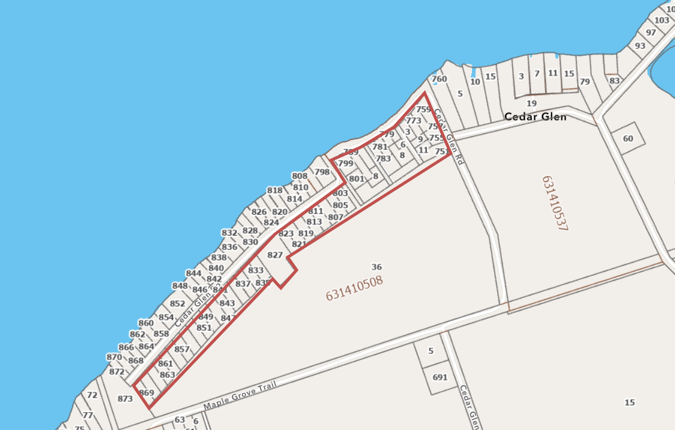

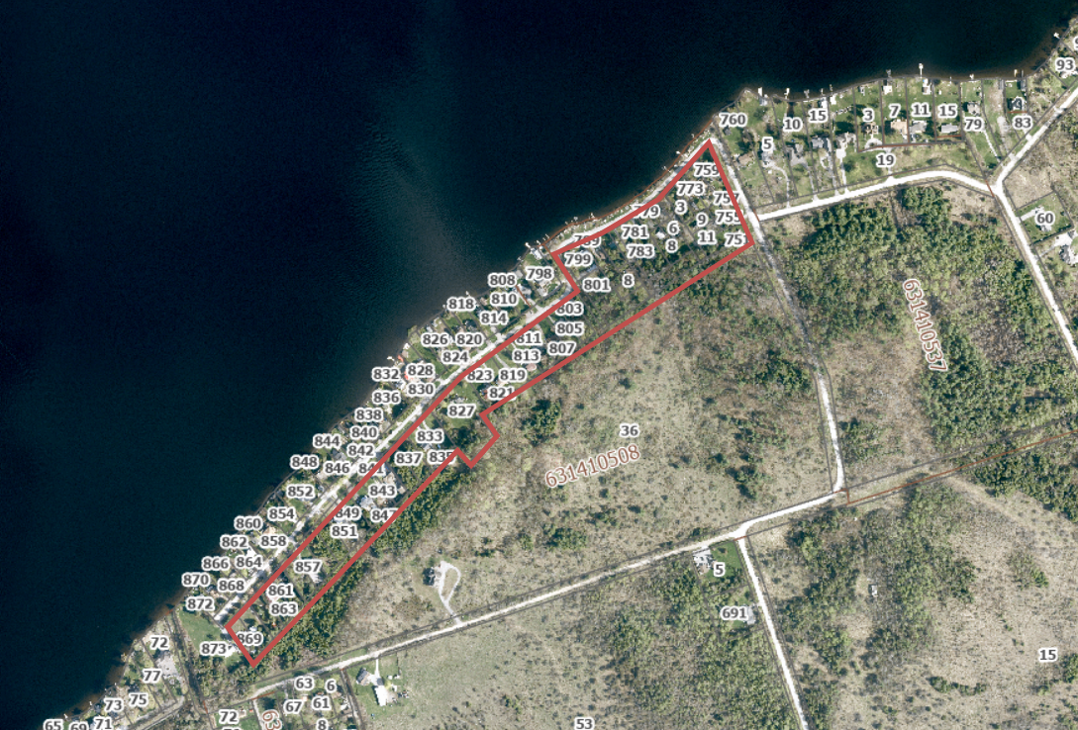

Where the road allowance is unopened, the preferred alternative will usually be for the shoreline road allowance to be sold to the adjoining private property, to merge with that parcel.
Where there is a travelled road between the docks and the associated residential lots, a lease rather than a license may be preferred by the dock owner and acceptable to the City.

