

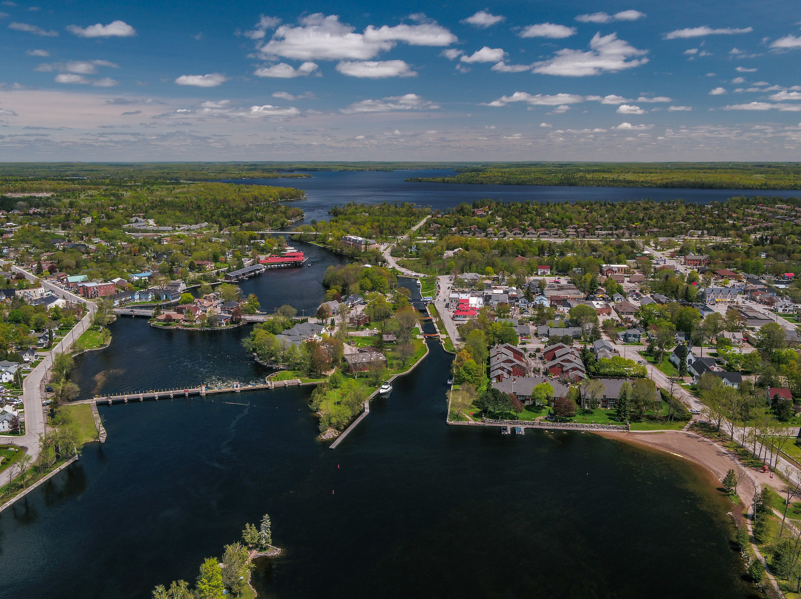
2026 – Lot Grading & Drainage Guidelines
Engineering and Corporate Assets
Development Services – Building and Septic Division


Table of Contents
Table of Contents 1
1.0 General 2
2.0 Lot Grading and Drainage Plans 2
2.1 General 2
2.2 Grading 3
2.3 Infrastructure 4
2.4 Private Infrastructure 4
2.5 Natural Features 4
3.0 Lot Design Criteria and Standards 4
3.1 General 4
3.2 Grades 5
3.3 Swales 5
3.4 Rainwater Leaders and Sump Pumps 5
3.5 Driveway 5
3.6 Rear Lot Catch Basins 6
3.7 Retaining Walls (Not Covered by the Ontario Building Code) 6
3.8 Flow Mitigation 6
4.0 Mandatory General Notes 6
5.0 Foundation Stage 7
6.0 Grading Certification (Subdivision Only) 8
7.0 Final Lot Grading Certification (Subdivision Only) 8
8.0 Definitions 9

1.0 General
All lot grading plans shall demonstrate that drainage is self-contained, drains to a protected outlet (i.e. natural watercourse, municipal roadside ditch, drainage easement, etc.) and does not negatively impact adjacent properties or City infrastructure. The grading plan shall also identify major storm flood routing (up to and including the 100-year or regional storm event) to ensure that no houses, detached garage, other structures or septic tanks/tile beds are located within potential flood lines.
All lot grading plans shall conform to (have regard for) all applicable City By-Laws and Ontario Provincial Standards.

2.0 Lot Grading and Drainage Plans
The preliminary submission shall consist of the lot grading and drainage and/or site plan in electronic format. If unable to provide in electronic format a single hard copy with all applicable information on a single page document may be submitted. The following information shall be clearly stated on the plan:
- Building Permit Number;
- Legal Description;
- Civic Address (if available);
- Roll Number;
- Owner/Applicant;
- Builder;
- Geographic Area (Former Township, Village, etc.);
- Submission Number or Revision Information;
- Mandatory General Notes (Refer to Section 4.0);
- Source of Survey Data – Confirmed by an OLS; and
- Canadian Geodetic Vertical Datum of 2013 (CGVD2013).
The required details and content of the Lot Grading and Drainage Plans shall include the following:

General
- North arrow;
- Legend including all symbols and elevation formats shown on the plan;
- Key plan indicating the area of the proposed development;
- Drawings at a scale that is legible and suitable to adequately identify the development and satisfy the requirements contained herein;
- Street names of all roads within and bordering the proposed development;
- Any existing or proposed blocks and easements;
- Elevation reference (detailed survey monument information);
- All information shall be indicated in metric units;
- Existing contours at a maximum of 0.5m intervals extending 10m beyond the limits of the property (or development);
- Any existing and/or proposed easements; and
- Signed, sealed, and dated by a licensed Professional Engineer (P.Eng.) or an Ontario Land Surveyor (O.L.S.).

Grading
- Location of existing and proposed buildings, including those on adjacent lands with setback information from property lines;
- Proposed grade elevations for all buildings and lot corners;
- Proposed minimum opening elevations where the property is subject to flood plain regulations in accordance with applicable zoning by-law and local conservation authority;
- Finished floor, top of slab, top of foundation wall, top of foundation at walkout, underside of footing, etc. for walkout elevations
- All driveway grades including elevations for break points;
- All exterior entrances, decks, and steps including the proposed grades at same;
- Intermediate point elevations of grade change delineating the overall grading of the lot;
- Direction of flow on lot lines including grade;
- Surface water runoff for all lots and roadways indicating direction of flow;
- All swales including elevations and grades at regular intervals;
- Typical or proposed swale cross-section details;
- Proposed cross-section details for any lot grading or drainage configurations which deviate from the City’s guidelines;
- All 3:1 slopes and any required terracing with intermediate grades; and
- All proposed and/or existing culverts including culvert material type, diameter, gauge, length, and invert elevations.

Infrastructure
- All rear yard catch basins along with the rim elevation and invert elevation for any outlet pipe(s);
- Locations of all catch basins, maintenance holes, fire hydrants, street lights, transformers, utility pedestals, sidewalks, curbs, water valves, fencing, and plantings;
- Proposed and/or existing lateral locations including water, sanitary, and storm with size, material, invert elevations, slopes etc.;
- Existing and/or proposed locations for all municipal infrastructure;
- Existing and/or proposed road elevations including boulevard cross-fall, etc.;
- Existing and/or proposed ditch elevations (including top/toe of slope);
- The zone of influence for any buried rear or side yard infrastructure; and
- The locations of all buried utilities and utilities laterals.

Private Infrastructure
- Existing and/or proposed locations of private septic systems and private water supply systems including setbacks from property line; and
- All sump pump and downspout (rain leader) discharge locations.
All lot grading plans shall conform and be coordinated with the sewage system plan as approved by the Supervisor Part 8 Sewage Systems.

Natural Features
- Watercourses and drainage ditches; and
- Areas regulated by a Conservation Authority (if applicable).

3.0 Lot Design Criteria and Standards

General
- The total grade differential for rural lots shall be designed to minimize impact on the natural topography while maintaining general conformance with the lot grading standards and guidelines contained herein.
- In general, all residential lots shall be graded to provide rear to front drainage.
- Existing and proposed vegetation removals shall be identified.

Grades
- The maximum lot surface grade shall be 6%. Slopes of 3:1 (3 horizontal to 1 vertical) shall be used to take up any additional grade difference.
- The maximum grade differential is not to exceed 15%, including 3:1 slopes.
- All urban boulevard areas shall be graded with a constant slope from the curb to the street limit (minimum slope to be 2%; maximum slope to be 8%), and all water boxes, maintenance hole covers, valve boxes, etc. shall be set flush with the finished sod surface.
- All lot surfaces shall be constructed to a minimum grade of 2%.
- The grade of any front walkway shall not exceed 6%.

Swales
- All swales shall have a minimum grade of 2%.
- The minimum depth of a swale shall be 150 mm.
- The maximum depth of a rear yard swale shall be 500 mm.
- The maximum depth of a side yard swale shall be 500 mm.
- The maximum side slope on any swale shall be 3:1.
- All drainage swales shall be located on one side of the common lot line between adjacent lots and not along the property line, unless subject to a Plan of Subdivision

Rainwater Leaders and Sump Pumps
- The location of the discharge point of sump pump outlets shall be indicated on the plan.
- The location of all proposed discharge points for rainwater leaders shall be indicated on the plan.

Driveway
- Driveways shall not be used as outlets for any swales.
- Driveways shall have appropriate clearances from all above ground and underground utilities.
- All driveways shall have a minimum grade of 2.0% and a maximum grade of 7.0%. In some cases, the City may permit a maximum grading of 8.0%; however it is not recommended under normal circumstances and should be employed only in exceptional cases.
- All driveways shall have positive drainage away from any proposed buildings.
- Driveways with negative grade from the property lines shall have a high point at the property line and positive drainage from the property line to the street.

Rear Lot Catch Basins
- The use of rear lot catch basins and outlet pipes should be minimized.
- If necessary, any proposed rear lot catch basin shall be located entirely on one lot.
- Any outlet pipe is to be located on the same lot with at least a 0.35m offset from all property lines.
- Rear Lot Catch Basins to be designed and constructed in accordance with City Storm and Stormwater Management Infrastructure Guidelines.

3.7 Retaining Walls (Not Covered by the Ontario Building Code)
- The use of retaining walls is to be avoided.
- Designs should consider the use of grading solutions.
- Maintenance and replacement of retaining walls shall be the responsibility of the owner on whose land the wall is constructed.
- Retaining walls or structures will not be permitted to encroach upon the City’s Right of Way.

3.8 Flow Mitigation
- The use of flow mitigation measures such as but not limited to; rock check dams, riprap outlets, flow spreaders, soakaway pits, infiltration trenches or basins, bioretention swales, enhanced grass swales etc. should be avoided and only permitted to control release rates, minimize downstream impact or where a protected outlet is not available or feasible.
- It is recommended that all flow mitigation measures are designed by a Professional Engineer with expertise in drainage and stormwater management.
- All proposed flow mitigation measures require a certification letter from the designer at the time of installation to confirm the features were placed and constructed in accordance with the approved grade plan.

4.0 Mandatory General Notes
The following notes are required on all grading plans. Site specific notes will be added to the grading plan as required:
- Drainage shall be self-contained on site by the construction of swales or drain to a protected outlet. Drainage shall not impact adjacent properties.
- Sediment and erosion control measures shall be implemented to prevent migration of silt and sediment from the subject lot to any adjacent lot, including municipal right-of-way. Special care shall be taken to ensure that silt and sediment laden surface water does not enter any watercourses or environmentally sensitive area, either overland or through the storm drainage system. The owner/builder shall comply with all directives issued by any of the environmental agencies.
- Interim grading measures may be required during building construction to ensure that drainage does not adversely affect the neighboring properties. Rough grading of the property shall be completed such that drainage is contained on site or controlled to a protected outlet.
- All downspouts and other drainage discharge points shall discharge on to a splash pad or approved equivalent (and locations to be shown as per 3.4).
- Sump pump discharge points must be wholly within private property.
- The owner/builder is responsible for obtaining utility and servicing locates prior to any works.
- All disturbed areas are to be sodded or seeded over a minimum of 150mm of topsoil or approved equivalent.
- The owner/builder must obtain a Road Occupancy Permit from Public Works prior to any works within the Municipal road allowance.
- No elevations will be less than 0.15m between final grade and Top of Foundation Wall.
- A copy of the ‘Reviewed by Engineering’ lot grading and drainage plan is to be on site for reference at all times during construction.
- The submission of this plan represents that Owner hereby acknowledges that any grading changes that occur through the construction that result in adverse effects to existing adjacent properties will result in an as-constructed site grading plan will be required.
- Swales with less than 2% slope have potential for ponding (if applicable).

5.0 Foundation Stage
Prior to continuation of house construction proceeding beyond the basement level, the Ontario Land Surveyor shall provide the City with a completed As- Constructed Foundation Control Certificate. The original ‘Reviewed by Engineering’ lot grading and drainage plan must be attached and submitted with this form. This form must be completed using the current City template confirming that foundations have been constructed:
- In conformance with the footings and top of foundation wall elevations, including walk out foundation elevations, as designed and shown on the approved grading plan.
- Sited entirely on the correct lot and conforming to the applicable Zoning By-Law.
Certification of foundation elevations by the Ontario Land Surveyor shall be taken to mean conformance with the approved grading plan and will include verification of top of foundation wall, any steps in the foundation (if applicable), the garage sill, and backfill.
Please note that non-conformance to either siting or foundation elevations shall be brought to the City’s attention for further direction prior to proceeding with construction.
By-Law No. 2012-019 (as amended), a by-law to provide for the administration and enforcement of the Building Code Act, 1992 within the City of Kawartha Lakes, states the following regarding the foundation control stage:
  - On the completion of the foundation for a detached, semi-detached, triplex, fourplex or townhouse dwelling, the applicant shall submit to the Chief Building Official confirmation from an Ontario Land Surveyor certifying the location and elevation of the top of the foundation wall and confirming general conformity with the approved site grading plan, prior to a framing inspection being undertaken.
  - On the completion of the construction of a building, or part of a building, the Chief Building Official may require submission of a set of plans of the building or part of a building, as constructed, together with a plan of the survey prepared and certified by an Ontario Land Surveyor showing the location of the building.

6.0 Grading Certification (Subdivision Only)
Lots that have been created through a Subdivision Agreement will typically have been included in an overall lot grading and drainage plan, also known as Schedule ‘E’ of the Registered Subdivision Agreement. The individual lot grading and drainage plan must conform to the overall plan. Certification shall be submitted, signed, and sealed by the Engineer of Record confirming the individual lot design is in accordance with the overall plan, including the tie down information/service card for each lateral/service connection.

7.0 Final Lot Grading Certification (Subdivision Only)
As part of the subdivision process, the Engineering Department requires that a final Lot Grading Certificate be issued for each lot by the Engineer. The Engineer must confirm that lot(s) are in general conformance with the Overall Lot Grading Plan on file with the City and that they certify the Final Grading of these Lots. This certification also includes confirmation of the specific data on the as-constructed foundation control certificate.
Once the final lot grading certification is received by the Engineering Department, the individual lot grading component of the Subdivision Agreement is fulfilled. The requirement for an overall as-built lot grading and drainage plan is still the Owner’s responsibility prior to assumption of the subdivision.
Until final assumption of a subdivision, the resolution of grading issues will be the sole responsibility of the Owner and Engineer.
Alterations to Certified Lot Grading by property owners are at the risk of the owner. If grading alterations result in adverse impacts to adjacent private properties, owners may be subject to civil litigation.

8.0 Definitions
“Adjacent” means beside, abutting or contiguous to.
“City” means the Corporation of the City of Kawartha Lakes.
“Drainage” means the natural or artificial removal of surface and sub-surface water from an area to a preferred receiving area.
“Engineer” means a Professional Engineer, licensed in the Province of Ontario with Professional Engineers Ontario (PEO).
“Erosion” means the detachment and corresponding movement of soil, sediment, or rock fragments by water, wind, ice, or gravity.
“Finished Grade” means the approved elevation of ground surface of the site upon which fill has been placed or grade of land that has been altered.
“Protected Outlet” means a City owned storm sewer, roadside ditch, drainage easement, conservation authority regulated area, watercourse, etc.
“Retaining Wall” means a structure that has been designed and constructed to resist the lateral pressure of soil where there is a change in ground elevation greater than 1.0 metre.
“Sediment and Erosion Control” means the design of measures to reduce the transport of sediment to ditches, wetlands, streams, rivers, and other bodies of water.
“Surveyor” means a professional in good standing with the Association of Ontario Land Surveyors as governed by the Surveys Act, R.S.O. 1990, as amended.
“Swale” means a depression in the ground surface, utilized for the purpose of conveying surface drainage.
“Watercourse” means a natural or manmade ditch, channel or swale in which water flows, either continuously or intermittently.
“Zone of Influence” means the angle of repose is determined by 45-degree lines extending from the invert of pipe upwards to the finished grade. This is influenced by the type of soil present and where the building or structure is located which will result in external vertical loads exerting stress on a pipe.

