
Application Guide

Activity Categories & Descriptions Overview
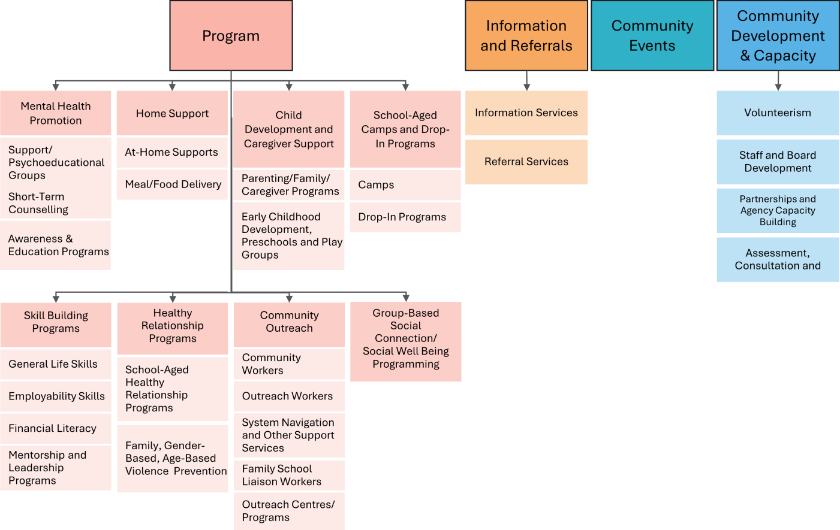
Please note each Municipality may vary in their focus, design and delivery of the provincial priorities which may effect funding outcomes.

Programs: A “Program” is a service offering intended to support community members as participants. Programs can further be categorized by Program Types and Subtypes. Participation is typically recurrent or ongoing, where participants attend more than once.
Below is a chart of the programs in more detail
Programs: A “Program” is a service offering intended to support community members as participants. Programs can further be categorized by Program Types and Subtypes. Participation is typically recurrent or ongoing, where participants attend more than once.
Below is a chart of the programs in more detail
Type | Preventive Focus | Sub Type | Description/Examples
Mental Health Promotion | Programs that promote mental health, educate and raise awareness about mental health and addiction topics, and build coping skills among individuals and families.  Note: Mental Health Support from a Family Liaison is included in Community Outreach. | Support/Psychoeducational Groups | Facilitated support groups designed to strengthen individuals' capacity to navigate life's challenges and their unique lived experiences.  Examples:  - Grief/loss groups  - 2SLGBTQQIA+ groups  - Caregiver support groups  - Psycho educational groups (group-based art therapy, equine therapy, music therapy)
Mental Health Promotion |  | Counselling Services | Short-term supportive counseling, typically 6-8 sessions for individuals, couples, and families, with a general focus on building resilience and developing strategies to manage challenges, including family conflict mediation.  Modalities may include:  - Individual or family art, music, or equine therapy  - Anger management  - Marriage counselling
Mental Health Promotion |  | Awareness & Education Programs | Workshops and seminars aimed to educate individuals, families, and the community on various mental health topics, targeting either the general public or specific groups.  Examples of topics may include:  - Addiction issues  - Suicide prevention  - Drug and alcohol use  - Anxiety management
Type | Preventive Focus | Sub Type | Description/Examples
Home Support | Programs designed to assist individuals in remaining in their homes, thereby preventing social isolation and reducing the necessity for higher levels of care. These programs offer preventive, non- medical home support and companionship to community members in their residences, including seniors and individuals with  disabilities. | At Home Supports | Programs that help individuals live independently and remain in their homes longer.  Examples:  - Light housekeeping  - Minor home maintenance  - Snow removal  - Lawn maintenance  - In-home or telephone companionship  - Emergency/medical alert systems
Home Support |  | Meal/Food Delivery | Meal and food delivery programs designed to assist individuals who may need support in accessing food and essential meals.  Examples:  - Volunteer and coordination support for meal delivery programs  - Delivery of food from food banks
Child Development & Caregiver Support | Programming designed to support the wellbeing and capacity of families through programs/activities for children, youth, and their caregivers or parents. | Parenting/ Family/ Caregiver Programs | Programs that offer parents education, resources, and support to foster positive parenting practices. Activities may be designed for parents and caregivers alone or for parents and caregivers alongside their children and youth.  Examples:  - Healthy routines and parenting resilience program  - Child development education sessions
Child Development & Caregiver Support |  | Early Childhood Development, Preschools and Play Groups | Programs designed to enhance the social and emotional development of preschool-aged children. Activities may involve children exclusively or include parents and caregivers alongside children. The primary emphasis of the program is on fostering the child's social development.  Examples :  - Drop-in children’s groups  - Registered children's group
School-aged Camps and Drop-in Programs | Programs intended to help children and youth develop confidence, build social or life skills, develop relationships, or social responsibility. | Camps | Camps are programs that are typically offered during specific times of the year, such as summer, spring break, and fall. The primary objective of camps is to foster confidence, social skills, life skills, and social responsibility. They usually operate for a full day or span multiple days.  Examples:  - Youth summer camps  - Spring break camps  - Cultural camps
School-aged Camps and Drop-in Programs |  | Drop-In Programs | Drop-In Programs offer opportunities for school-aged participants to build relationships and skills or develop confidence, typically in a group setting, without having to register ahead of time.  Examples  - Before/after school drop in programs  - Youth drop-in programs
Type | Preventive Focus | Sub Type | Description/Examples
Skill Building Programs | Programs that help participants build life skills to develop their independence and resilience, adopt healthy lifestyles, and build protective factors. | General Life Skills | Programs that assist participants in developing essential life skills.  Examples:  - Babysitting programs  - Home Alone programs  - Digital and technology use/safety programs  - Workshops offering general information, self- improvement opportunities, and skill-building initiatives that support independence and resilience
Skill Building Programs |  | Employability Skills | Programs that assist participants in gaining employability skills:  Examples:  - Entrepreneurship education  - Confidence and self-advocacy programs  - Soft skills development programs
Skill Building Programs |  | Financial Literacy | Programs designed to assist participants in developing financial literacy skills and competencies.  Examples:  - Financial employment programs  - Budgeting skills programs  - Fraud prevention programs
Skill Building Programs |  | Mentorship and Leadership Programs | Programs that provide participants with opportunities to  develop leadership skills and access mentorship.  Examples:  - Youth councils  - Intergenerational programs  - Youth leadership conferences
Healthy Relationship Programs | Programs that educate, raise awareness, build social skills and protective factors to prevent violence and encourage constructive interpersonal relationships in the community  Note: marriage counselling and anger management is under Mental Health Promotion | Family, Gender-Based or Age-Based Violence Prevention | Programs to prevent gender-based violence, elder abuse, family violence, and other relationships violence.  Examples:  - Seniors’ Healthy relationship programs  - Boundaries Programs
Healthy Relationship Programs |  | School-Aged Healthy Relationship Programs | Programs aimed at promoting healthy relationships and mitigating negative interactions among school-aged children.  Example:  - Anti-bullying programs
Type | Preventive Focus | Sub Type | Description/Examples
Community Outreach Programming | Proactive support and assistance offered to individuals or families. This may involve aiding individuals or families in developing their social networks, enhancing their resilience, accessing and navigating available support and resources, or building social and life skills. | Community Workers | Provide a variety of preventative support services, particularly in small communities. They serve a broad audience rather than a specific population and may deliver programs and services at multiple locations throughout the community.  Examples of the supports provided may include:  - Social well-being assistance  - Home support programs  - Resource navigation services  - Community program support
Community Outreach Programming |  | Outreach Workers | Engage with specific groups or at-risk populations. These programs often involve multiple interactions with the same individual and may foster an ongoing supportive relationship with clients.  Examples of titles for this type of program may include:  - Outreach Worker  - Community Support Worker  - Community Resource Navigator  - Senior Coordinator  - Case Manager  - Liaison Worker  - Cultural Navigator
Community Outreach Programming |  | System Navigation and Other Support Services | Assist individuals in accessing various services or supports. These engagements usually involve either one-time interactions or a brief series of contacts.  Examples of such assistance include:  - Navigation support for accessing benefits and services  - Assistance with completing forms  - Volunteer income tax programs  - Support for individuals who may require more in-depth assistance than what a standard “referral” offers, but are not supported by an “outreach worker”
Community Outreach Programming |  | Family School Liaison Workers | Facilitate the relationship between the home, school environment and community organizations supporting student achievement and capacity building.  Example:  - Family School Wellness Program
Community Outreach Programming |  | Outreach Centres  And Programs | Initiatives that operate from designated locations, providing support to at-risk individuals to enhance their stability and capacity.
Group Based Social Connection/  Social Well Being Programming | Build relationships and support networks, foster a sense of belonging, and prevent social isolation. | N/A | These initiatives are typically group-based programs that foster social connections and promote overall wellbeing.  Examples:  - Social connection programs  - Newcomers' programs  - Peer groups  - Community garden programs  - Community kitchen programs  - Movement classes for social connection  - Elder gatherings

Community Development and Capacity Building: includes activities that promote, encourage and facilitate the development of stronger communities through the strengthening of FCSS programs. These acitivities involve volunteers and/or staff.
Type | Description
Volunteerism | Actions and initiatives that enhance the capacity for volunteerism and acknowledge the contributions of volunteers to local FCSS programs.  Examples:  - Volunteer training  - Volunteer recognition  - Volunteer development
Staff and Board Development | Activities and actions that build the skills and capacities of FCSS staff members and boards.  Examples:  - Leadership programs  - Training  - Conferences
Partnerships and Agency Capacity Building | Any inter-agency work aimed at fostering the development of stronger communities. This encompasses initiatives such as capacity building in other organizations, partnership development, and providing funding for capacity building efforts. This also includes participation on boards and committees.  Examples:  - Interagency tables or networks
Assessment, Consultation and Evaluation | These efforts aim to gain a deeper understanding of community and organizational needs and to plan appropriate interventions and evaluate progress. Include internal FCSS activities as well as FCSS- related community consultations.  Examples:  - Community consultations  - Strategic planning  - Social planning  - Community needs assessments  - Program evaluations

