

DUNDALK SANITARY SEWAGE COLLECTION SYSTEM

2025 Annual Performance Report 110-W601
May 2026

Prepared by: The Township of Southgate

TABLE OF CONTENTS
Introduction 4
Background 4
System Description 5
System Summary 5
  - Monitoring Data & Interpretation 5
  - Operational Problems & Corrective Actions 6
  - Calibration, Maintenance & Repairs 6
  - Complaints & Actions Taken 6
  - Alterations to the Authorized System 6
  - Overflows & Spills 7
  - Reduction Efforts (Overflows, Spills) 7
- Closing 7

LIST OF APPENDICES

Appendix A – Sanitary Infrastructure Map

Introduction
This report has been prepared by the Township of Southgate to satisfy the requirements of Schedule E, Section 4.6 of the Environmental Compliance Approval for a Municipal Sewage Collection System that has been issued to the Township of Southgate by the Ontario Ministry of Environment, Conservation and Parks (MECP).

The report covers the period from January 1 to December 31, 2025, for the following municipally owned and operated wastewater collection system:

Wastewater Collection System Information

Consolidated Linear Infrastructure – Environmental Compliance Approval (CLI-ECA_

ECA Number: 110-W601

Issue Number: 1

Issue Date: March 2, 2023

Background

An Operations and Maintenance (O&M) Manual dated June 2023, has been prepared for the Authorized System, in accordance with Schedule E, Condition 3.2 of the CLI ECA No. 110-W601, Issue No. 1. Consistent with Schedule E, Condition 3.2 of the CLI ECA for the System, the objective of the operation and maintenance of the System is to protect sources of drinking water, such as those included in the Standard Operating Policy for Sewage Works, and any applicable local Source Protection Plan policies.
The information, photographs, interpretations, maintenance records, etc. collected in accordance with the O&M Manual are to be compiled into the Performance Report for the System and submitted to the MECP Director on or before March 31st of each calendar year, covering the period from January 1st to December 31st of the preceding calendar year. Consistent with the CLI ECA for the Township’s System, each Performance Report shall contain, but not be limited to, the following:
- Summary of all monitoring data, as well as an interpretation of the data and any conclusions drawn from the data evaluations about the need for future modifications to the System or system operations.
- Summary of operating problems and corrective actions taken.
- Summary of all calibration, maintenance, and repairs carried out on any major structure, Equipment, apparatus, mechanism, or thing forming part of the System.
- Summary of complaints related to the System and the steps taken to address the complaints.
- Summary of Alterations to the System including a list of Alterations that pose a significant Drinking Water Threat.
- Summary of system overflows and spills within the Collection System.
- Summary of the efforts made to reduce Collection System Overflows, Spills, STP Overflows, and/or STP Bypasses.
The Performance Reports for the System can be viewed at the following location:
  - Electronic copy format at https://www.southgate.ca/

System Description

The Township’s Sanitary Collection System (System) is composed of the Dundalk sanitary collection system within the urban boundary of Dundalk.
The System is designed to convey sanitary sewage and consists of a combination of sanitary sewers, maintenance holes and a Township operated sewage pumping station.

System Summary

Monitoring Data & Interpretation

Month | Total Flow | Average Day Flow m3 | Max Flow m3
January | 45366 | 1463 | 2655
February | 30187 | 1078 | 1438
March | 98201 | 3168 | 6595
April | 72770 | 2426 | 7827
May | 39432 | 1272 | 1685
June | 31800 | 1060 | 1292
July | 29421 | 949 | 1361
August | 24614 | 794 | 1021
September | 21711 | 724 | 864
October | 22045 | 711 | 775
November | 30683 | 1023 | 1521
December | 40591 | 1309 | 2422
Total / Year | 486821 | 1331 | 7827

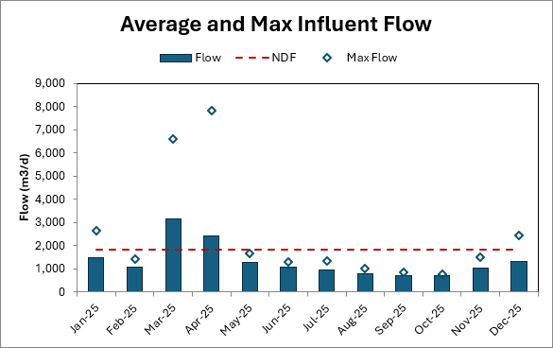

Operational Problems & Corrective Actions

There were no known operating problems encountered regarding the Township System during Calendar Year 2025.

Calibration, Maintenance & Repairs.

During the year 2025, the Township continued its regular maintenance program including regular inspection and cleaning of sewers and maintenance holes on an as-needed basis. The inlet structure for Cell 1 was cleaned out using a vac truck. The structure between Cells 3 and 4 was cleaned out using the vac trailer. There was a thick, sludge-like matter in the structure. The foot valve on the Jet pump was replaced. Calibration of the influent and effluent flow meters was completed in October 2025 by a third party. Calibration of the TSS and DO analyzer probes were completed by Southgate staff in January and July. Handheld calibration by a third party on February 3, 2025. Both blowers received oil changes and visual inspection.

Complaints & Actions Taken

There were 3 complaints in 2025. All were related to sewage backing up.

February 26, 2025 – A previous repair of the sanitary service at property line had become dislodged causing a blockage. A vac truck exposed the piping. A plumber cleared the blockage. The vac truck flushed the service and the main. The plumber repaired the piping.

July 10, 2026 – Dumping station backing up. Vac truck called in to flush and camera. Flushing was unsuccessful. Upon camera investigation, a rock was found jammed in the piping. Vac truck exposed the piping. Southgate staff cut out a section of piping, removed the rock and repaired the piping.

December 18, 2025 – Sewer back up. Plumber on-site. Plumber had removed half a garbage bag of flushable wipes from the sanitary service. Upon investigation, found the manhole full of flushable wipes causing a blockage. A vac truck was called in, cleaned the manhole and flushed the sewer main. Plumber cleared the sanitary service and took a video of the cleared service.

4.5 Alterations to the Authorized System

- Within the System the following sewers are currently owned and operated by the developer under the existing ECA Number 0612-C35HWP.
Flato Developments East Phases 7, 8, and 10 (Existing ECA 0612-C35HWP)
  - 1,367 m = 200mm diameter.
  - 287 m = 250mm diameter.

Within the above noted Phases, there is also a sewage pumping station that has been included. Director Notification was previously submitted.

- Within the System the following sewers are currently under construction and will be owned by the developer. Director notification will be provided under separate cover.

Flato Developments East Phase 11
  - 513m = 200mm diameter

- Within the System the following sewers are currently under construction and will be owned by the developer. Director notification will be provided under separate cover.

White Rose Phase 3
  - 520m = 200mm diameter.

Overflows & Spills

There were no known overflows or spills within the System within the 2025 Calendar Year.

Reduction Efforts (Overflows, Spills)

Within the 2025 Calendar Year the Township prepared and implemented the emergency discharge plan for the Dundalk Wastewater Treatment Facility (WWTF).
Additionally, the Township continues to prepare and issue the annual Reserve Capacity Calculations for The Dundalk WWTF to ensure that treatment capacity is maintained and achieves the PPCP. The Reserve Capacity Calculations are publicly reported and adopted through Council.

Closing:

The above Annual Performance Report is respectfully Submitted by Township of Southgate.


Cory Henry – Public Works Manger – Water Operations
Reviewed by the Township of Southgate

SWMF
MCKENZIEST.
T.

STREETB
ST

TODD CR.

STREET D
BRAD EX

OPEN SPACE
TOWNSHIP OF SOUTHGATE

STREET A
FENNELLST.
AITCHISONAVE.
STREET C
STREET B
WETLANDBUFFER
WETLANDLIMIT
SIGNIFICANTW H
WETLAND

SWMF
MIDDLETONST.
CORBETTST.
DOCL
SWMF

WILSON CRT.
DOYLE ST.
SWMF

HIGHPOINT ST.
GLENELG ST.
BRADLEY ST.
AVE.
PINE CRT.
GREY ST.

McGREGOR CRT.
DUNDALK FIRE DEPARTMENT
DUNDALK ST.
KING'S HIGHWAY No. 10
TORONTO ST.

BRAEMORE ST. W.
OSPREY ST.
PROTON ST.
KEPPEL (ROW)
IDA ST.

BRAEMORE ST. E.

D4 WATER TOWER

WELL D4
MACDOWELL ST.
MILL ST.

HIGH POINT
PUBLIC SCHOOL
PROTON ST.

ARENA
OWEN SOUND ST.
HOLLAND ST.

LEGEND:

MAIN ST. WEST
McAULEY (ROW)
SINCLAIR ST.

VICTORIA ST.
YOUNG ST.
ALICE ST.

MAIN ST. EAST

SHEFFIELD ST.
McAULEY ST.
RUSSEL ST.

PROPERTY
ARTEMESIA ST.

MANHOLES

TOWNSHIP OF SOUTHGATE BOUNDARY EXISTING PROPERTY LINE
PROPOSED DEVELOPMENT PARCELS WATERCOURSES
WETLAND (GRCA)

SANITARY MANHOLE
MUNICIPALLY OWNED MANHOLE NUMBER
MANHOLE NOT YET ADOPTED BY MUNICIPALITY

HANBURY ST.

WELL D3

HAGAN ST.

GOLD ST.
RUSSELL ST.

HAGAN STREET
ROWE'S LN

WERRY AVE. RIDLEY CR.
NIXON ST.

SEWER SIZE (N/A TO WWTF)
ELM ST.
200mm Ø 250mm Ø 300mm Ø 375mm Ø 450mm Ø 525mm Ø 600mm Ø

SEELEY AVE.
MORROW CIR.
BELL CIR.
15.25m EASEMENT
WERRY AVE.
RIDLEY CR.
SANITARY PUMPING STATION

PROTON COMMUNITY SCHOOL

WELL D5

VANDUSEN AVENUE
ELM ST.

MOODY STREET

MOODYST.

VANDUSEN AVENUE
RUSSELLST.

STOCKSAVE.

PARK

SPS
VAND AVE.

COLGANCRES.

PIPE MATERIAL
ASBESTOS CEMENT CONCRETE
POLYVINYL CHLORIDE
MATERIAL
FLOW DIRECTION
COLOUR CODED DIAMETER

SLOPE LENGTH
IN-LINE CLEAN OUT AND SHUT-OFF VALVE

MORGANAVE.
WRIGHTAVE.
RUSSELLST.
SYMINGTONST.

FORCEMAIN

SWMF

SWMF
SWMF
IDA ST.

MILLINERAVE.
MILLNERAVE.
MCALLISTERST.
COMMERCIAL DEVELOPMENT

ECO-PARKWAY

150Ø PVC SDR 26 SERIES 160 FILTER WASTE PUMP DISCHARGE

ACCESS ROAD

FILTER WASTE RETURN

MANHOLE T-2 APPROX. LOCATION

BOTTOM OF BANK

INFLUENT CHAMBER
CHEMICAL STORAGE FACILITIES (ALUM STORAGE)
BYPASS

CHEMICAL
METER BUILDING
RAW SEWAGE PUMPING STATION

150Ø PVC SDR 26

250Ø A.C. TO M.H. T-1 MANHOLE T-1
APPROX. LOCATION
BYPASS
INLET

100Ø SCH 80 CPVC AIRMAIN
c/w TRACER WIRE

BLOWER
CONTROL STRUCTURE 2 APPROX. LOCATION
BYPASS
INLET APPROX. LOCATION
300Ø OVERFLOW
300Ø D.I.
SERIES 160 FILTER WASTE PUMP DISCHARGE
APPROX. LOCATION 250Ø P.E.

BUILDING
CELL No.4
CELL No.3
RAW SEWAGE
FORCEMAIN

NORMAL OPERTING WATER LEVEL: 506.45DUNDALK LANGOORMOANL SOPERTING WATER LEVEL: 506.47

BOTTOM OF CELL: 504.67 VOLUME: 46,660 m3
BOTTOM OF CELL: 504.67 VOLUME: 46,660 m3

POST AERATION CELL

FILTER BUILDING
CONTROL STRUCTURE 8 (OVERFLOW)
APPROX. LOCATION
CELL 4 INLET APPROX. LOCATION

CONTROL STRUCTURE 7 APPROX. LOCATION

CELL 3 INLET APPROX. LOCATION
BOTTOM OF BANK
NOTES:
This is a schematic representation of the sanitary sewer

400Ø EMERGENCY
300Ø CELL No.4
400Ø CELL No.3
300Ø CELL No.3

450Ø PVC SDR 35 FILTER EFFLUENT

500Ø P.E. EFFLUENT
OVERFLOW

500Ø P.E.
FILTER BY-PASS
INFLUENT
BOTTOM OF BANK

CONTROL STRUCTURE 3 APPROX. LOCATION
EFFLUENT

BOTTOM OF BANK

300Ø CELL No.3 INFLUENT

MANHOLE No.1 APPROX. LOCATION

INFLUENT

BYPASS CONTROL STRUCTURE APPROX. LOCATION

BYPASS

CONTROL STRUCTURE 6 APPROX. LOCATION
collection system. While this drawing and its detail views are shown to a scale, symbols and sanitary sewers are not plotted to
scale. This mapping should be used for general reference purposes only.

CONTROL STRUCTURE 1
300Ø CELL No.2
BOTTOM OF BANK
BOTTOM OF BANK
CELL 1 INLET

(OVERFLOW)
APPROX. LOCATION
EFFLUENT
CELL 1 INLET APPROX. LOCATION

CONTROL STRUCTURE 5
APPROX. LOCATION

CONTROL STRUCTURE 4 APPROX. LOCATION

CELL No.2
APPROX. LOCATION

LAGOONS

CELL No.1

NORMAL OPERTING WATER LEVEL: 507.96 BOTTOM OF CELL: 506.15
WASTEWATER TREATMENT FACILITY
DUNDALK
NORMAL OPERTING WATER LEVEL: 509.30 BOTTOM OF CELL: 507.50
FUTUREROW

VOLUME: 57,600 m3 VOLUME: 57,600 m3

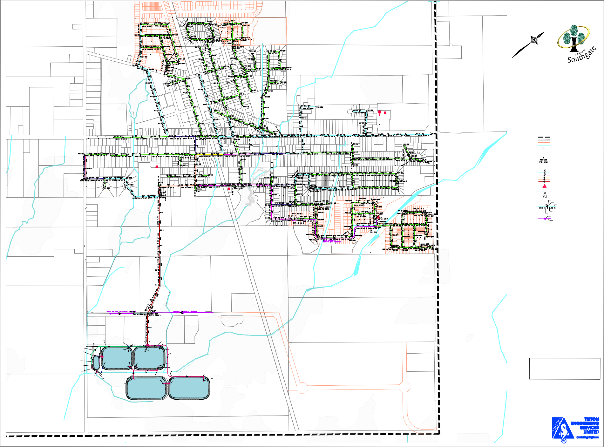

BOTTOM OF BANK

BOTTOM OF BANK

DUNDALK SANITARY COLLECTION SYSTEM

