

DUNDALK STORMWATER MANAGEMENET SYSTEM

2025 Annual Performance Report 110-S701
May 2026

Prepared by: The Township of Southgate

TABLE OF CONTENTS
Introduction 3
Background 3
SWM System Description 4
System Summary 4
  - Monitoring Data & Interpretation 4
  - Summary and Interpretation of Environmental Trends 4
  - Summary of Operating Problems and Corrective Actions 4
  - Summary of Inspection and Maintenance Activities 5
  - Summary of Calibration and Maintenance on Monitoring Equipment 5
  - Summary of Complaint Related to the SWM System 5
  - Summary of Alterations to the Authorized System 5
  - Summary of Spills or Abnormal Discharge Events 6
  - Summary of Performance Improvements or Corrections 6
  - Summary of Status of Action Items from Previous Reporting Year 6
  - Summary of Action items for the Calendar year 2026……………………………………………………………………………………………..6
Closing 6

LIST OF APPENDICES

Appendix A – Storm Infrastructure Maps

Introduction

The Township of Southgate has prepared this Annual Performance Report (Performance Report) covering Calendar Year 2025 for the Township’s Municipal Stormwater Management (SWM) System (SWM System or Authorized System), consistent with the requirements of Schedule E, Condition 5.2 of the Township’s Consolidated Linear Infrastructure Environmental Compliance Approval (CLI ECA) No. 110-S701 Issue No. 1, dated March 2nd, 2023.

Background

An Operations and Maintenance (O&M) Manual, dated June 12th, 2023, has been prepared for the Township’s SWM System, in accordance with Schedule E, Condition 3.2 of the CLI ECA No. 110-S701, Issue No. 1.
The information collected in accordance with the O&M Manual is to be compiled into the Performance Report for the SWM System and submitted to the MECP Director on or before April 30th of each year, covering the period from January 1st to December 31st of the preceding calendar year. Consistent with the CLI ECA for the Township’s SWM System, each Performance Report shall contain, but not be limited to, the following:
- Summary of all monitoring data, as well as an interpretation of the data and overview of the condition and operational performance of the Authorized System and any adverse effects on the natural environment.
- Summary and interpretation of environmental trends based on all monitoring information and data for the previous five (5) years.
- Summary of any operating problems encountered, and corrective actions taken.
- Summary of all inspections, maintenance and repairs carried out on any major structure, equipment, apparatus, mechanism, or thing forming part of the Authorized System.
- Summary of the calibration and maintenance carried out on all monitoring equipment.
- Summary of any complaints related to the SWM System received during the reporting period and steps taken to address the complaints.
- Summary of all alterations to the Authorized System within the reporting period that were authorized by the CLI ECA, including a list of alterations that pose a Significant Drinking Water Threat. Any drawings maintained for the SWM System must be updated to reflect alterations to the Authorized System within 12-months of them being placed into service.
- Summary of all spills or abnormal discharge events.
- Summary of actions taken, including timelines, to improve or correct performance of any aspect of the Authorized System.

- Summary of the status of actions for the previous reporting year.
The Performance Report is to be made available, on request and without charge, to the public who are served by the Authorized System and shall be published electronically to the Owner’s internet website for free public viewing by June 1st of the same reporting year. Therefore, the Performance Reports for the SWM System can be viewed at the following locations:
  - Electronic copy format at https://www.southgate.ca/

SWM System Description

The Township’s SWM System is composed of the Dundalk SWM system and the Harris and Hoffman subdivision private SWM systems.
The Dundalk SWM system is designed to manage stormwater (i.e., not designed to convey sanitary sewage or combined sewage) and consists of a combination of storm sewers, culverts, ditches/swales, SWM facilities and outlets (i.e., stormwater collection and SWM facilities). Details of the Township’s SWM System are provided in Schedule B of CLI ECA No. 110-S701, Issue No. 1.

System Summary

SWMF includes Aunt Mary’s Storm Pond, Uncle Tom’s Storm Pond East, Uncle Tom’s Storm
West (Hoffman Subdivision ECA 6665-6HPSXE), Elm St Storm Pond (Flato West ECA # 6031- ACPJE4), Sheffield Storm Pond.

There are several developer operated SWMF which include: Todd Crescent East, Todd Crescent West, Moody St, Russell St, Glen Elg St and Milliner Ave.

Monitoring Data & Interpretation

Site visits were conducted as necessary to ensure that the operation is in accordance with the conditions of the CLI ECA. These routine activities did not identify any operational issues that needed to be addressed by appropriate remedial measures.

Summary and Interpretation of Environmental Trends

There has not been sufficient monitoring data collected for the Township’s SWM System to interpret environmental trends. It is anticipated that environmental trends can be interpreted after a period of 5 years of monitoring data collection, which began in the Calendar Year 2024.

Summary of Operating Problems and Corrective Actions

There were no known operating problems encountered in regard to the Township’s SWM System during Calendar Year 2025.

Summary of Inspection and Maintenance Activities

Site visits were conducted as necessary to ensure that the operation is in accordance with the conditions of the CLI ECA. These routine activities did not identify any operational issues that needed to be addressed by appropriate remedial measures. Signage was installed in June of 2025 at all Southgate maintained SWMF.
Date | SWMF | Activity | Comments
05/21/2026 | Sheffield Storm Pond | Annual inspection | No comments
05/21/2026 | Elm St Storm Pond | Annual inspection | No comments
06/11/2026 | Sheffield Storm Pond | Installed sign
06/11/2026 | Elm St Storm Pond | Installed signs
06/16/2026 | Aunt Mary’s Storm Pond | Annual inspection | Installed sign
06/16/2026 | Uncle Tom’s Storm Pond East | Annual inspection
06/16/2026 | Uncle Toms’s Storm Pond West | Annual inspection
06/24/2026 | Uncle Tom’s Storm Pond East | Installed sign
06/24/2026 | Uncle Tom’s Storm Pond West | Installed sign

Summary of Calibration and Maintenance on Monitoring Equipment

There is no monitoring equipment associated with the Township’s SWM System, therefore, there are no calibration and/or maintenance activities on monitoring equipment to report for Calendar Year 2025.

Summary of Complaint Related to the SWM System

There were no known complaints received related to the Township’s SWM System in Calendar Year 2025.

Summary of Alterations to the Authorized System

Alterations made to the authorized system in 2025 years and/or corrections from the CLI-ECA 110-S701 Issue No. 1 are as follows:
Table B1, Infrastructure Maps to be updated and replaced with the following maps (included in Appendix A).:
    - Southgate Stormwater Management System – Infrastructure Map dated April 2025.
Alterations authorized in 2024 under CLI ECA No. 110-S701 Issue No. 1 are summarized below.
- Within the System the following sewers are currently owned and operated by the developer under the existing ECA Number 0612-C35HWP.
  - Flato Developments East Phases 7, 8, and 10
o 858m > 250 – 500mm
o 1,202m > 500 – 1050mm
o 0.332m > 1050mm
- Within the System the following sewers are currently under construction and will be owned by the developer. Director notification will be provided under separate cover.
  - Flato Developments East Phase 11
o 1,045 km > 250 – 500mm
o 532 km > 500 – 1050mm
    - Stormwater Management Facility

- Within the System the following sewers are currently under construction and will be owned by the developer. Director notification will be provided under separate cover.
o 285m > 250 – 500mm
- Stormwater Management Facility

Summary of Spills or Abnormal Discharge Events

There were no known spills or abnormal discharge events related to the Township’s SWM System in Calendar Year 2025.

Summary of Performance Improvements or Corrections

Typical routine operation activities completed during the reporting period include grass cutting and vegetation and weed control.
Street sweeping was conducted in April 2025 as part of the Township’s typical maintenance schedule. Street sweeping following the spring snowmelt reduces pollutant loads and suspended solids accumulation within downstream receivers (i.e., ditches, storm sewers, and SWM facilities, etc.).

Summary of Status of Action Items from Previous Reporting Year

There were no action items from the previous report in 2024.

  - Summary of Action Items for the Calendar year of 2026

Conduct annual inspections of SWMF.
Complete sampling requirements for the Elm St storm pond. 3 samples taken after 15mm of precipitation in the preceding 24 hours. Samples tested for TSS and temperature. 2 samples taken between May and September.

Closing:

The above Annual Performance Report is respectfully Submitted on behalf of the Township of Southgate.


Cory Henry
Public Works Manger – Water Operations

STREETC

SWMF

FUTURE ROW

STREETD

SPACE
OPEN
PARK

STREETB

STREETA

FUTURE ROW
STREETF
STREETH
STREETI

STREETA
OPEN

SWMF
MCKENZIEST.

STREETE

STREETB
STREETG

TODD CR.
OGS

STREET D
STREET B
BRADLEYSTREET EXTENSION
450 450 450

250

300

SPACE
CORBETTST.
TOWNSHIP OF SOUTHGATE

STREET A
FENNELLST.
AITCHISONAVE.
STREET C
300

250

300

250 250 250 250 250

250
300 250 250 250 250

300
WETLANDBUFFER
WETLANDLIMIT
OGS
SIGNIFICANTWILDLIFEHABITAT/WETLAND
SWMF
200

SWMF
MIDDLETONST.
CORBETTST.
DOCLOUGHEEDAVE.

300

WILSON CRT.
400 CSP
450 CSP
450 CSP
400 CSP 450 CSP
500 CONC.
DOYLE ST.
250
300

SWMF

450 450
450 CSP
450 CSP
GLENELG ST.
BRADLEY ST.
300 CSP
PINE CRT.

375
500 CSP
GREY ST.
600 500
375
300
450 CSP
HIGHPOINT ST.

1630x1120 CSP

300 CSP
450 CSP
600 CSP
750
300
450
1050 CSP
450 CSP

300
375

500
300 300
450
375
250
600
450
600
200
200
450 CSP

450
DUNDALK FIRE DEPARTMENT
450
450

McGREGOR CRT.
250
750
DUNDALK ST.
200
200 CSP
250
600

450 CSP 450 CSP
KING'S HIGHWAY No. 10
450 CSP
600 x 600 CONC.
450
300
300
TORONTO ST.
250
600

300
300
450 CSP 450 CSP
KEPPEL (ROW)
600

375
750
OSPREY ST.
MILL ST.
300

BRAEMORE ST. W.
450 CSP
375
750 750
PROTON ST.
300

450 CSP
IDA ST.
450 CSP
200
300
250
330
200
CSP
375

BRAEMORE ST. E.
3 - 750 CSP
MACDOWELL ST.

D4 WATER TOWER
600

WELL D4
300

HIGH POINT
300
600
OWEN SOUND ST.
300
HOLLAND ST.
300
PUBLIC SCHOOL
300
PROTON ST.

MAIN ST. WEST
300
300
McAULEY (ROW)

300
300
200

1.65w x 0.95h CSPA

300
300

300
300

600

1650 x 1100
300
300
300
ARTEMESIA ST.

250
300
1050 CSP
150

MAIN ST. EAST
300
750

1800 x1200 CSPA
300

450 CSP
150

ARENA

300
300

LEGEND:
300 300

450

PROPERTY
450
375
375
375 375

150
300

300
450

150

200

300
450

300
300

150

300

450

450

380

300 300
300
300
600

750
450
375

300
300
300

1090x1725
1800x1200 CSP
450
450
300
450

450 450
200

450 450

300

300
1475x910 CSPA
1475 x 910 C30S0PA
380

300 (NOT CONFIRMED IF REMOVED)
200
YOUNG ST.
300 (NOT CONFIRMED IF REMOVED)

300
300 300

450
300
750

375 375 300
300

200
McAULEY ST.
300
300
200

VICTORIA ST.

1200x900

1.72 x 1.1
200
915 CSP

250

250
450
450

250

375
ALICE ST.
200
200
375
375

250

300
450
200 200

250

1200 CSP
300
375
525
TOWNSHIP OF SOUTHGATE BOUNDARY EXISTING PROPERTY LINE
PROPOSED DEVELOPMENT PARCELS WATERCOURSES
SINCLAIR ST.
WETLAND (GRCA)
250

250
250

300

450 CSP
100 150

450 CSP

1600 x 1000 CSPA

900 CSP
200

300 (NOT CONFIRMED IF REMOVED)
375
NIXON ST.
300
300 300
CONCRETE CULVERT

250

450
450
250

1800x900 CONC BOX CULVERT
450

SHEFFIELD ST.
750
250 375

450

525

250

675

300

675

600 CSP

FACILITY
675

STRUCTURES
300
RUSSEL ST.
375 375

WELL D3
450
525
525
300
300

375

6.0m WIDE x 0.9m RISE
ROWE'S LN
ELM ST.
300
375
300
300
13.2m LENGTH OPEN BOTTOM PRECAST CONCRETE CULVERT
375
300

WERRY AVE.
300 750 525 600
525
600
375
300
750

4500x1400mm OPEN BOTTOM ARMTEC BRIDGE
300
300
29.0m LENGTH PLATE CSP BOX CULVERT

RIDLEY CR.
RUSSELL ST.
375
300
375
450

STORM MANAGEMENT
250

600 CSP

600 CSP
375 375
375
375
375
375
300

600 CSP
STORM MANHOLE
CATCHBASIN AREA DRAIN

HANBURY ST.

600 CSP

600
MORROW CIR.
BELL CIR.
15.25m EASEMENT
375
300
300
300
300
300
300
300
300

300

HAGAN

600 CSP
300
300
300
600
28.0m LENGTH PLATE CSP BOX CULVERT
525

ST.
300
600

PROTON
GOLD ST. 375
450
250

2-12.0m OF 1630mmx1120mm ARCH CULVERT
300
250

450 CSP

300 CSP
300
300

WELL D5
825
825

450 CSP
375
300
300
300
300

250

600 CSP
300
300
600

HAGAN STREET
250
750
250

VANDUSEN AVENUE
900
ELM ST.
WERRY AVE.
OGS
250
525
300
300
300
525
300
525
375 375
375
300
300
300
300
300 300

900
300
825
525
300
300
600
300
300

SEELEY AVE.
300 300

VANDUSEN AVENUE
900 900 900
300
300
250
300
250
300
450
300
300
375
450
300
300
300
300
300
525
675
675
675

4500x1400mm OPEN BOTTOM ARMTEC BRIDGE
825
825
300
300 450 525
300
300
300
375

RIDLEY CR.
300
750
750
300
300
750
675
375
375
300
375

PARK
300
375
825
375
900
600

600 HDPE
450
525

450 CSP 300 CSP

600 CSP
500 HDPE
300
300 750
525
300
DIAMETER (mm)
FLOW DIRECTION STORM SEWER

600 CSP
300
DIAMETER (mm)
380 CSP MATERIAL

CULVERT DITCH/DRAIN
CATCHMENT BOUNDARY
300
300

COMMUNITY SCHOOL
300
525

400 CSP 450 CSP 450 CSP450 CSP

450 CSP
900
250
250

2 - 750 HDPE
300

MOODY STREET
825
300
OGS
450
375
450

MOODYST.

350 CSP
900
300
375 375
300
300
300

1200
375
300

1200
RUSSELLST.
375
375
525

825
375
250

STOCKSAVE.
300
300
300 300
375

300
VANDUSENAVE.
300

SPS
525
300 675

375

375
375
375

COLGANCRES.
300 300 300 300 300
300
300

300 300

300
300

300
300

300

300

300

300
CATCHMENT I.D. CATCHMENT INDICATOR
AREA (HECTARES)

ISOLATED / CONTAINED
300
300

1200

450 CSP 400 CSP 450 CSP
450
300
300
300
300
300

825
300
300
300
WRIGHTAVE.
RUSSELLST.
MORGANAVE.

300
675
STORM SYSTEM

1200
1200
675
525
450

300
750
750
750
750
750
750
900
300
MILLNERAVE.

750

300
MCALLISTERST.
300
300 375

450

300

300

300 300
300

SWMF

400 CSP
975

300
900
975

1200

750 825
300

300
900
1200
1200
300

300

300
375

300 300

300

300

300 375

2400mm WIDE x 1200mm RISE

450 CSP
IDA ST.
600
300
300

300

300

MILLINERAVE.
525
SYMINGTONST.
450 300
300 450

300

450
COMMERCIAL DEVELOPMENT

22.0m LENGTH CONC. BOX CULVERT
450
675

450 CSP 450 CSP

450 CSP

450 CSP
525
675
675
675
675
MSWF
SWMF

675
675
750
750
450
675
450

600

450
600

450

300

1800mm WIDE x 1200mm RISE

450 CSP 300 CSP
15.0m LENGTH
PRECAST CONCRETE BOX CULVERT

300 CSP

300 CSP

300 CSP

ECO-PARKWAY

300 CSP

300 CSP

3000mm WIDE x 2400mm RISE PRECAST CONCRETE BOX CULVERT

17.5m LENGTH

300 CSP

300 CSP

450 CSP

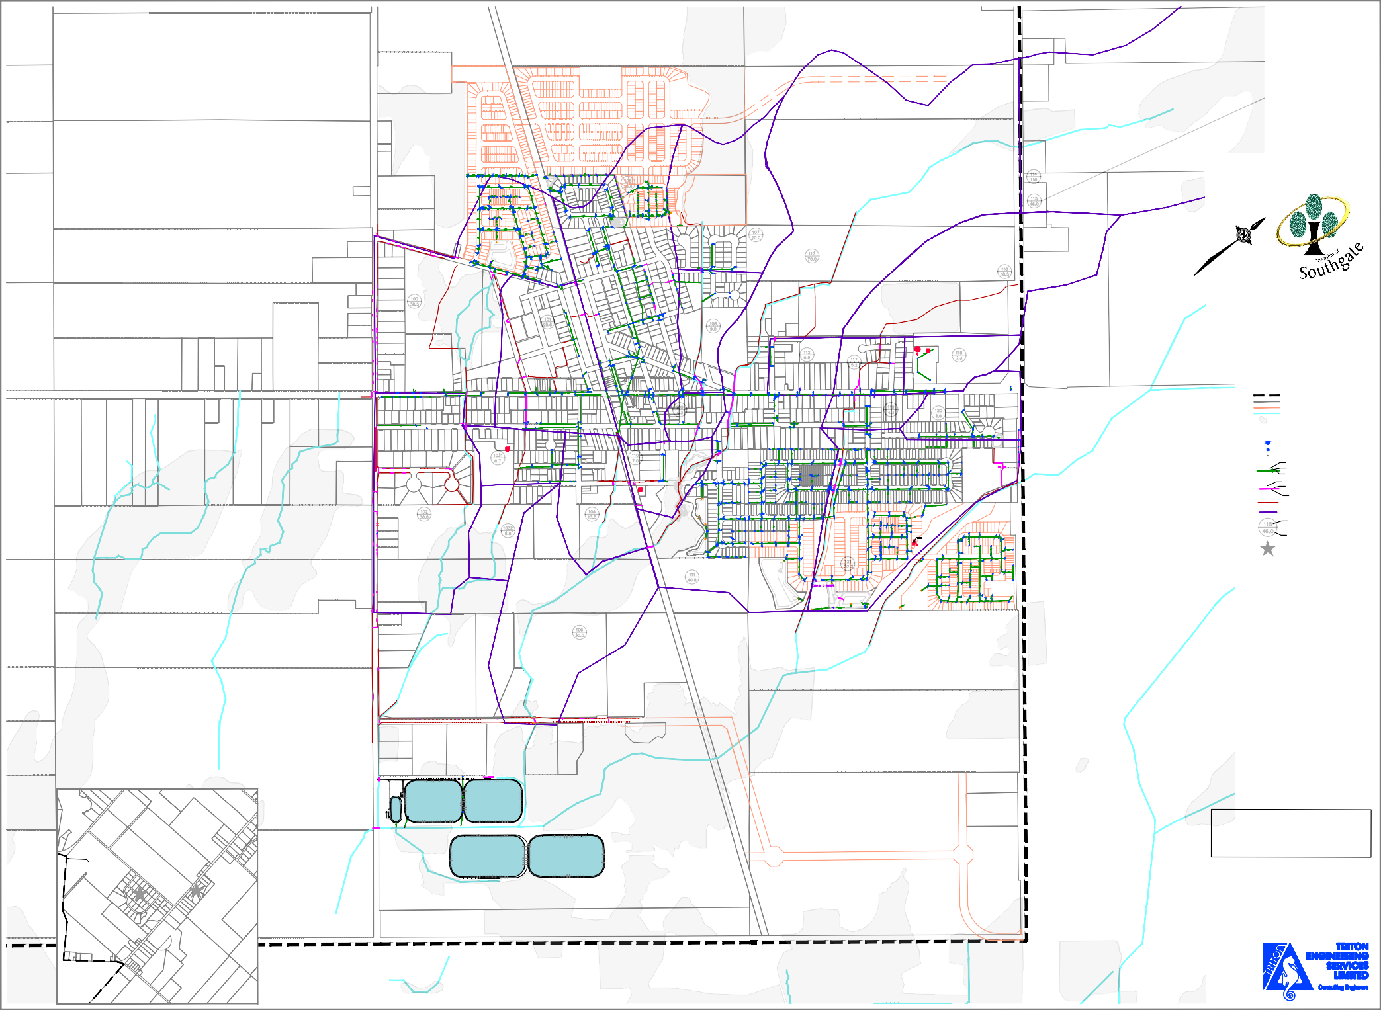
OTHER
COMMUNITIES

203
BOUNDARY BETWEEN TOWNSHIP OF
SOUTHGATE AND
WELLINGTON NORTH

Harris Subdivision

201/202

Hoffman Subdivision

BRIDGE

400Ø CELL 1 EMERGENCY OVERFLOW
250
500Ø P.E. POST AERATION EFFLUENT

WASTEWATER TREATMENT FACILITY

900 CSP

DUNDALK LAGOONS

250

250

DUNDALK LAGOONS

FUTUREROW

NOTES:
This is a schematic representation of the storm sewer collection system. While this drawing and its detail views are shown to a scale, symbols and storm sewers are not plotted to scale. This mapping should be used for general reference purposes only.

DUNDALK STORM AND DRAINAGE SYSTEM
JANUARY 2025
SCALE 1:3,000 A4179 R02 / A4160 R44/R45

